Will You Join Us?
# Participants  # Participants  # Participants  # Participants | 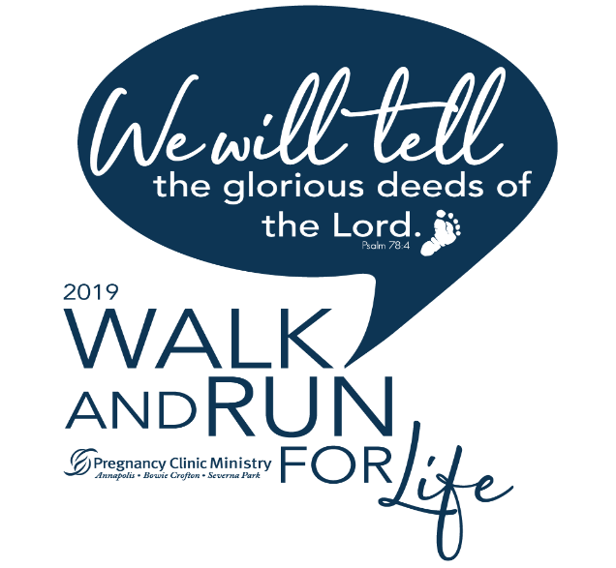
Saturday, September 21
Mid-Atlantic Community Church
2485 Davidsonville Rd, Gambrills
Our 2019
Goal:
 | #
Fundraising Participants
(Walkers/Runners/
Kids/Virtual Walkers)
Team Name: __________________________
www.WalkandRun.org

